***World famous architectural model***

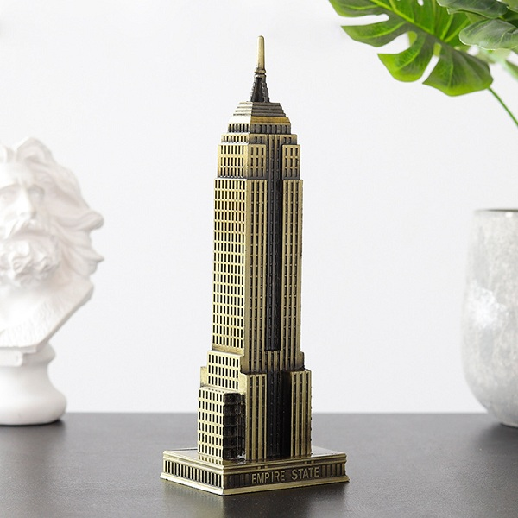

*World famous architectural models are miniature models of real buildings in the world. It is a miniature version of these works. The product is made of metal material. There are many models with different sizes and prices*